
COMSATS University Islamabad
Islamabad Campus
ECE 6
Subject: Data Communications & Computer Networks Marks: 30
Exam: Lab Sessional-2 Time: 60 Minutes
Instructor Asad Ali Malik Dated:06th May,2021

- Attempt all question.
- Email this word file on asadalimalik@comsats.edu.pk. Within due time which 60 minutes after receiving this paper.
- Late submissions will not be entertained.

Topology Diagram

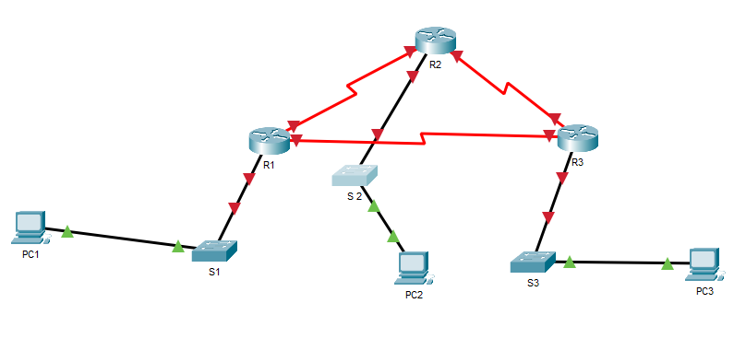

Given an IP address of 199.168.X.0/24, fill the table given below also fill the addressing table. Configure all interfaces and implement the routing protocol best suited also mention the reason behind your selection of a particular protocol. (‘X’ in IP is the registration number of each student. Hint: fill in first six and last)

Student Name: Muhammad Haris Irfan
Registration Number: FA18-BCE-090

No. of useable subnetworks: 8
No. useable Hosts per networks: 30
Subnet Mask: 255.255.255.224/27

# | Subnet | First host address | Last host address | Broadcast Address
1 | 199.168.90.0 | 199.168.90.1 | 199.168.90.30 | 199.168.90.31
2 | 199.168.90.32 | 199.168.90.33 | 199.168.90.62 | 199.168.90.63
3 | 199.168.90.64 | 199.168.90.65 | 199.168.90.94 | 199.168.90.95
4 | 199.168.90.96 | 199.168.90.97 | 199.168.90.126 | 199.168.90.127
5 | 199.168.90.128 | 199.168.90.129 | 199.168.90.158 | 199.168.90.159
6 | 199.168.90.160 | 199.168.90.161 | 199.168.90.190 | 199.168.90.191
Last | 199.168.90.224 | 199.168.90.225 | 199.168.90.254 | 199.168.90.255

Addressing table
Device | Interface | Ip Address | Subnet Mask | Default Gateway
R1 | Fast Ethernet | 199.168.90.1 | 255.255.255.224 | N/A
R1 | Serial interface | 199.168.90.33 | 255.255.255.224 | N/A
R1 | Serial interface | 199.168.90.65 | 255.255.255.224 | N/A
R2 | Fast Ethernet | 199.168.90.97 | 255.255.255.224 | N/A
R2 | Serial interface | 199.168.90.34 | 255.255.255.224 | N/A
R2 | Serial interface | 199.168.90.129 | 255.255.255.224 | N/A
R3 | Fast Ethernet | 199.168.90.161 | 255.255.255.224 | N/A
R3 | Serial Interface | 199.168.90.130 | 255.255.255.224 | N/A
R3 | Serial Interface | 199.168.90.66 | 255.255.255.224 | N/A
PC 1 |  | 199.168.90.2 | 255.255.255.224 | 199.168.90.1
PC 2 |  | 199.168.90.98 | 255.255.255.224 | 199.168.90.97
PC 3 |  | 199.168.90.162 | 255.255.255.224 | 199.168.90.161

Tasks
- Implement above network and routing in Packet Tracer
- Perform basic configuration tasks on each router
- Configure and activate Ethernet interfaces
- Include Output of show ip route command, show ip protocol command and show ip interface brief command.

OUTPUT:
I selected OSPF configuration as it is the shortest path first protocol and is used to distribute ip routing information thoughout a single System in an IP network, moreover I was also comfortable with its configuration, which was a partial reason I selected this.
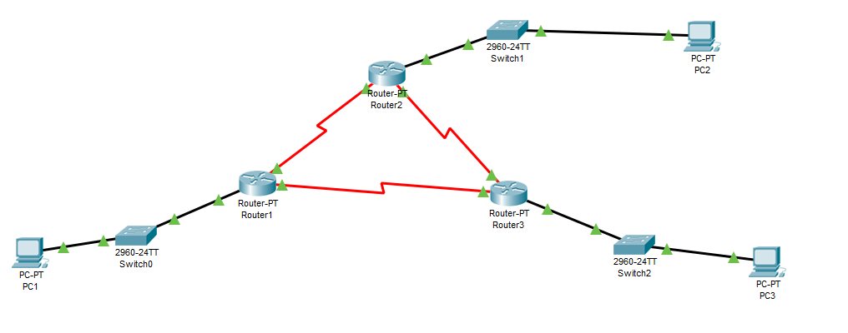
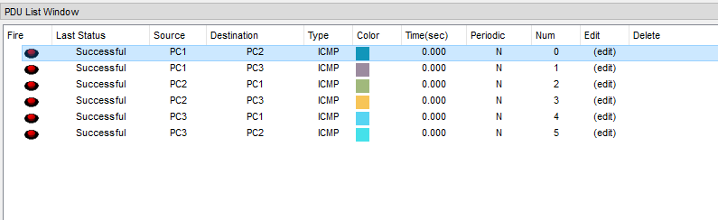
This table shows successful Packets sent between all PCs.

- Router 1:
Show ip route:
Router>show ip route
Codes: C - connected, S - static, I - IGRP, R - RIP, M - mobile, B - BGP
D - EIGRP, EX - EIGRP external, O - OSPF, IA - OSPF inter area
N1 - OSPF NSSA external type 1, N2 - OSPF NSSA external type 2
E1 - OSPF external type 1, E2 - OSPF external type 2, E - EGP
i - IS-IS, L1 - IS-IS level-1, L2 - IS-IS level-2, ia - IS-IS inter area
* - candidate default, U - per-user static route, o - ODR
P - periodic downloaded static route

Gateway of last resort is not set

199.168.90.0/27 is subnetted, 6 subnets
C 199.168.90.0 is directly connected, FastEthernet0/0
C 199.168.90.32 is directly connected, Serial2/0
C 199.168.90.64 is directly connected, Serial3/0
O 199.168.90.96 [110/65] via 199.168.90.34, 00:07:44, Serial2/0
O 199.168.90.128 [110/128] via 199.168.90.34, 00:04:54, Serial2/0
[110/128] via 199.168.90.66, 00:04:54, Serial3/0
O 199.168.90.160 [110/65] via 199.168.90.66, 00:04:54, Serial3/0

Show ip protocol:
Router>show ip protocol

Routing Protocol is "ospf 1"
Outgoing update filter list for all interfaces is not set
Incoming update filter list for all interfaces is not set
Router ID 199.168.90.65
Number of areas in this router is 1. 1 normal 0 stub 0 nssa
Maximum path: 4
Routing for Networks:
199.168.90.0 0.0.0.31 area 0
199.168.90.32 0.0.0.31 area 0
199.168.90.64 0.0.0.31 area 0
Routing Information Sources:
Gateway Distance Last Update
199.168.90.65 110 00:05:42
199.168.90.129 110 00:06:18
199.168.90.161 110 00:05:42
Distance: (default is 110)

Show ip interface brief:
Router>show ip interface brief
Interface IP-Address OK? Method Status Protocol
FastEthernet0/0 199.168.90.1 YES manual up up
FastEthernet1/0 unassigned YES unset administratively down down
Serial2/0 199.168.90.33 YES manual up up
Serial3/0 199.168.90.65 YES manual up up
FastEthernet4/0 unassigned YES unset administratively down down
FastEthernet5/0 unassigned YES unset administratively down down

- Router 2:
Show ip route:
Router#show ip route
Codes: C - connected, S - static, I - IGRP, R - RIP, M - mobile, B - BGP
D - EIGRP, EX - EIGRP external, O - OSPF, IA - OSPF inter area
N1 - OSPF NSSA external type 1, N2 - OSPF NSSA external type 2
E1 - OSPF external type 1, E2 - OSPF external type 2, E - EGP
i - IS-IS, L1 - IS-IS level-1, L2 - IS-IS level-2, ia - IS-IS inter area
* - candidate default, U - per-user static route, o - ODR
P - periodic downloaded static route

Gateway of last resort is not set

199.168.90.0/27 is subnetted, 6 subnets
O 199.168.90.0 [110/65] via 199.168.90.33, 00:09:48, Serial2/0
C 199.168.90.32 is directly connected, Serial2/0
O 199.168.90.64 [110/128] via 199.168.90.33, 00:07:11, Serial2/0
[110/128] via 199.168.90.130, 00:07:11, Serial3/0
C 199.168.90.96 is directly connected, FastEthernet0/0
C 199.168.90.128 is directly connected, Serial3/0
O 199.168.90.160 [110/65] via 199.168.90.130, 00:07:38, Serial3/0
Show ip protocol:
Router#show ip protocol

Routing Protocol is "ospf 1"
Outgoing update filter list for all interfaces is not set
Incoming update filter list for all interfaces is not set
Router ID 199.168.90.129
Number of areas in this router is 1. 1 normal 0 stub 0 nssa
Maximum path: 4
Routing for Networks:
199.168.90.96 0.0.0.31 area 0
199.168.90.32 0.0.0.31 area 0
199.168.90.128 0.0.0.31 area 0
Routing Information Sources:
Gateway Distance Last Update
199.168.90.65 110 00:07:22
199.168.90.129 110 00:07:58
199.168.90.161 110 00:07:22
Distance: (default is 110)

Show ip interface brief:
Router#show ip interface brief
Interface IP-Address OK? Method Status Protocol
FastEthernet0/0 199.168.90.97 YES manual up up
FastEthernet1/0 unassigned YES unset administratively down down
Serial2/0 199.168.90.34 YES manual up up
Serial3/0 199.168.90.129 YES manual up up
FastEthernet4/0 unassigned YES unset administratively down down
FastEthernet5/0 unassigned YES unset administratively down down

- Router 3:
Show ip route:
Router#show ip route
Codes: C - connected, S - static, I - IGRP, R - RIP, M - mobile, B - BGP
D - EIGRP, EX - EIGRP external, O - OSPF, IA - OSPF inter area
N1 - OSPF NSSA external type 1, N2 - OSPF NSSA external type 2
E1 - OSPF external type 1, E2 - OSPF external type 2, E - EGP
i - IS-IS, L1 - IS-IS level-1, L2 - IS-IS level-2, ia - IS-IS inter area
* - candidate default, U - per-user static route, o - ODR
P - periodic downloaded static route

Gateway of last resort is not set

199.168.90.0/27 is subnetted, 6 subnets
O 199.168.90.0 [110/65] via 199.168.90.65, 00:08:14, Serial3/0
O 199.168.90.32 [110/128] via 199.168.90.129, 00:08:14, Serial2/0
[110/128] via 199.168.90.65, 00:08:14, Serial3/0
C 199.168.90.64 is directly connected, Serial3/0
O 199.168.90.96 [110/65] via 199.168.90.129, 00:08:49, Serial2/0
C 199.168.90.128 is directly connected, Serial2/0
C 199.168.90.160 is directly connected, FastEthernet0/0

Show ip protocol:
Router#show ip protocol

Routing Protocol is "ospf 1"
Outgoing update filter list for all interfaces is not set
Incoming update filter list for all interfaces is not set
Router ID 199.168.90.161
Number of areas in this router is 1. 1 normal 0 stub 0 nssa
Maximum path: 4
Routing for Networks:
199.168.90.160 0.0.0.31 area 0
199.168.90.128 0.0.0.31 area 0
199.168.90.64 0.0.0.31 area 0
Routing Information Sources:
Gateway Distance Last Update
199.168.90.65 110 00:08:39
199.168.90.129 110 00:09:15
199.168.90.161 110 00:08:39
Distance: (default is 110)

Show ip interface brief:
Router#show ip interface brief
Interface IP-Address OK? Method Status Protocol
FastEthernet0/0 199.168.90.161 YES manual up up
FastEthernet1/0 unassigned YES unset administratively down down
Serial2/0 199.168.90.130 YES manual up up
Serial3/0 199.168.90.66 YES manual up up
FastEthernet4/0 unassigned YES unset administratively down down
FastEthernet5/0 unassigned YES unset administratively down down

__________________________

